EDRC Use Case 1, Test Case 1, Section 7.2.2 Capacity Other
Revision of EDRC doc:

11 | Updated to reflect comments from David Price | K Willshaw  30 March 2015

Test case spec release 1.0

7.2.2 Capacity Other - TIP ID: N/A

Comment – valPropertyValue is xsd:float, not ExpressReal in the template.

Template Name: IndividualHasIndirectPropertyWithValue

Role Name | Role Type | Role Value
hasPossessor | dm:PossibleIndividual | EQUIPMENT Identifier
hasIndirectPropertyType | dm:ClassOfProperty | Selected Class as described in section 6.1.2
valPropertyValue | dm:ExpressReal | Value of Property
hasPropertyScale | dm:Scale | METRE CUBED PER HOUR

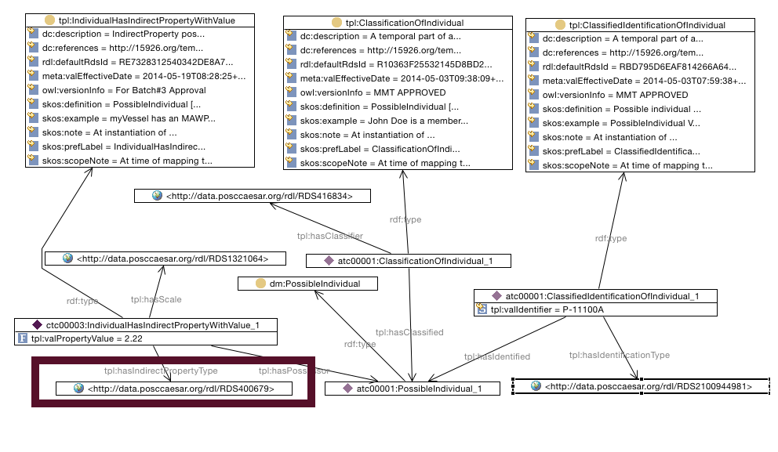

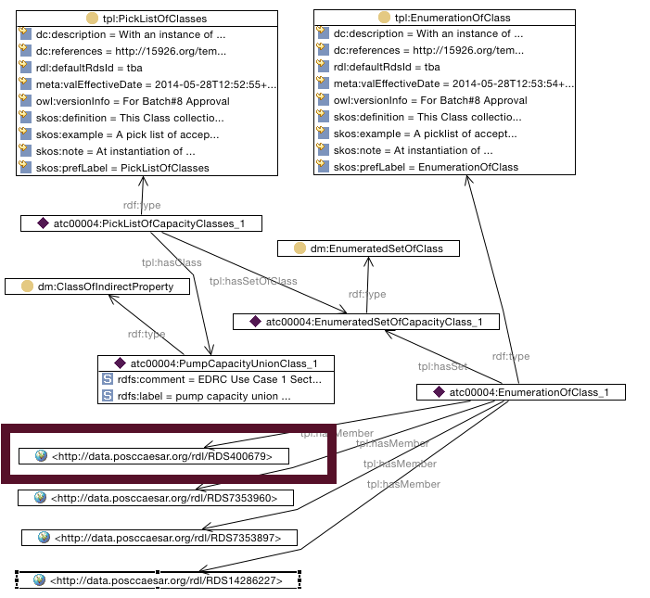

SPARQL to find Other Capacity of Pump

SELECT ?PumpIdentifier ?Property ?PropertyValue
WHERE {
?classificationofindividual tpl:hasClassified ?possibleindividual .
?classificationofindividual tpl:hasClassifier <http://data.posccaesar.org/rdl/RDS416834> .
?classificationofindividual rdf:type tpl:ClassificationOfIndividual .
?possibleindividual rdf:type dm:PossibleIndividual .
?classifiedidentificationofindividual tpl:hasIdentified ?possibleindividual .
?classifiedidentificationofindividual tpl:hasIdentificationType <http://data.posccaesar.org/rdl/RDS2100944981> .
?classifiedidentificationofindividual rdf:type tpl:ClassifiedIdentificationOfIndividual .
?individualhasindirectpropertywithvalue tpl:hasIndirectPropertyType ?Property .
?individualhasindirectpropertywithvalue tpl:hasPossessor ?possibleindividual .
?individualhasindirectpropertywithvalue tpl:hasScale <http://data.posccaesar.org/rdl/RDS1321064> .
?individualhasindirectpropertywithvalue rdf:type tpl:IndividualHasIndirectPropertyWithValue .
?classifiedidentificationofindividual tpl:valIdentifier ?PumpIdentifier .
?individualhasindirectpropertywithvalue tpl:valPropertyValue ?PropertyValue .
}

Questions

Should there be something in the test cases that relate this property type and value to the Other Capacity element in the datasheet?

